**Gas Leakage Monitoring and**

**Alerting System for Industries**

|  |  |
| --- | --- |
| **PROJECT NAME** | GAS LEAKAGE MONITORING & ALERTING SYSTEM FOR INDUSTRIES |
| **TEAM ID** | PNT2022TMID25975 |
| **TEAM MEMBERS** | 1. DASA SARANYA  2. KRISTAVARAPU RAMYA SRI  3. VANGALA SOWMYA  4. RAGAVI.B |
| **BRANCH** | ELECTRONICS AND COMMUNICATION ENGINEERING |

**Abstract:**

Liquefied Petroleum Gas (LPG) is a main source of fuel, especially in urban areas because it is clean compared to firewood and charcoal. Gas leakage is a major problem in the industrial sector, residential premises, etc. Nowadays, home security has become a major issue because of increasing gas leakage. Gas leakage is a source of great anxiety with ateliers, residential areas and vehicles like Compressed Natural Gas (CNG), buses, and cars which are run on gas power. The different types of gas sensors technologies including catalytic gas sensor, electrochemical gas sensors, thermal conductivity gas sensor, optical gas sensor and acoustic gas sensor are discussed together with their principle of operation. This proposed system also includes an alerting system for the users. The system is based on a sensor that easily detects a gas leakage. The proposed IOT to be installed through a manual approach or virtual approach is depending on the consumer interest. There were many instances experiencing the many people to become victims of this and also the environment to be also spoiled and it takes more time to purify the infected environment or to bring the affected environment to a normal level.

**Introduction:**

Gas leakage is a serious problem and nowadays it is observed in many places like residences, industries, and vehicles like Compressed Natural Gas (CNG), buses, cars, etc. It is noticed that due to gas leakage, dangerous accidents occur. In our daily lives, we are encountering many situations such as gas cylinder burns with negligence of the user in the kitchen, also many gas industries pipeline to be leaked and emitting toxic gas that harms the people living in the society, and many other situations depicting the consequences when the gas to be leaked outside. Liquid petroleum gas (LPG) is highly inflammable and can burn even at some distance from the source of leakage. This energy source is primarily composed of propane and butane which are highly flammable chemical compounds. These gases can catch fire easily. The reason for such explosions is due to substandard cylinders, old valves, no regular checking of gas cylinders, worn out regulators and a lack of awareness of handling gas cylinders. Therefore, the gas leakage should be detected and controlled to protect people from danger. Gas sensors are chemical sensors that are of paramount importance. A chemical sensor comprises of a transducer and an active layer for converting the chemical information into another form of electronic signal like frequency change, current change or voltage change.

**Literature Survey:**

* **Development of a Gas Leakage Detection System**

**[C. C. Nnokwe](https://www.semanticscholar.org/author/C.-C.-Nnokwe/2004956099), [B. Ubochi](https://www.semanticscholar.org/author/B.-Ubochi/10366896), [K. V. Onwuzuruike](https://www.semanticscholar.org/author/K.-V.-Onwuzuruike/2004948678)**

Liquefied Petroleum Gas (LPG) is a fundamental source of fuel in urban areas as a result of its comparatively higher calorific value and reduced impact on the environment. Due to the flammable nature of the gas, care must be taken in order to guarantee its safe use. In this work, a microcontroller-based gas leakage detection system is developed. The system detects leaked gas using MQ-6 gas sensor whose calibrated outputs are used to trigger an alarm and display gas levels on a liquid crystal display (LCD) for ambient gas concentrations above 100 PPM. Additionally, the system is configured to send an “EMERGENCY ALERT” message to a user’s mobile device in emergency situations.

**APPLICATIONS AND ADVANTAGES:**

* Low Weight Alert
* Local Audio Alarm
* Safety has always been an important criterion.
* **Gas leakage detection and alerting system using Arduino Uno**

**Syeda Bushra Shahewaz and Ch. Rajendra Prasad**

The presence of hazardous LPG gas leakage in a domestic, work place, also, stored gases container gas which exhibits ideal characteristic is use. For that sake, an alarm unit is used to vibrate an alarm which is buzzer. Buzzer gives an audible sign of the presence of LPG volume. The sensors are widely used to detect essence of propane, iso-butane, LPG and even smoke. The sensor has an advantage to combine a sensitivity response time. If the LPG sensor senses gas leak from work place or home, sensor output goes to active low (logic-0) condition. Arduino UNO is used in the project; low signals are overlooked by the Arduino and gas leakage is been noticed by the Arduino. The Arduino UNO turns on the LCD and buzzer. It even turns on the GSM modem after that, it continues to send messages SMS to mobile number specifically mentioned in the program of the source code for alerting danger to the people.

**ADVANTAGES AND APPLICATIONS:**

* Applicable usefully in the industrial and domestic purpose.
* In danger situations we are able to save the life by using this system.
* An alert is indicated by the GSM module.
* A sensor node senses gas like CO2, oxygen, propane.
* **GAS LEAKAGE DETECTION AND SMART ALERTING SYSTEM USING IOT**
* **(Shital Imade, Priyanka Rajmane, Aishwarya Gavali, V. N. Nayakwadi )Computer Dept.,BSCOER, Savitribai Phule Pune University, India**

Internet of Things aim towards making life simpler by automating every small task around us. As much is IoT helping in automating tasks, the benefits of IoT can also be extended for enhancing the existing safety standards. Safety, the elementary concern of any project, has not been left untouched by IoT. Gas Leakages in open or closed areas can prove to be dangerous and lethal. The traditional Gas Leakage Detector Systems though have great precision, fail to acknowledge a few factors in the field of alerting the people about the leakage. Therefore we have used the IoT technology to make a Gas Leakage Detector for society which having Smart Alerting techniques involving sending text message to the concerned authority and an ability performing data analytics on sensor readings. Our main aim is to proposing the gas leakage system for society where each flat have gas leakage detector hardware. This will detect the harmful gases in environment and alerting to the society member through alarm and sending notification

**APPLICATIONS AND ADVANTAGES:**

* Live-Monitoring and Control
* On-Demand Automatic Reordering Facility
* A UAV System for Autonomous Target Detection and Gas Sensing

IOT technology to make a Gas Leakage Detector for society which having Smart Alerting techniques involving sending text message to the concerned authority and an ability performing data analytics on sensor.

**Objective:**

The main objective of the proposed Gas Leakage Detection and Automatic Control System (GLDACS) is to provide a solution by designing an automatic system which can detect the leakage of liquefied petroleum gas (LPG) at home and control it by turning off the cylinder knob. A gas leakage detector becomes vital and helps to protect people from the dangers of gas leakage. A number of research papers have been published on gas leakage detection techniques

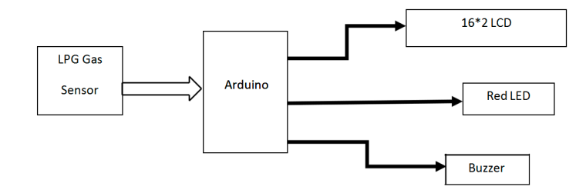

**Proposed Method :-**

The Internet of Things has permeated all spheres of life, from businesses to households and industries. IOT, which connects everything and everyone,

making the planet more intelligent and better than ever. However, this is only the start. Businesses must comprehend the prospects for value creation and methodically solve the underlying obstacles in order to fully realise the potential of the Internet of Things.

The Internet of Things (IoT) is a network of interconnected, physical items that can be accessed online. The term "thing" refers to an object that has been given an IP address and the capability to gather and send data over a network without the help of a person or human intervention. Examples of such objects are a person wearing a heart monitor or an automobile with built-in sensors.

The objects' inherent technology enables them to interact with interior conditions or the outside world, which has an impact on the choices made. Connected to an Internet of Things platform, which combines data from many devices and applies analytics to share the most useful information with applications created to answer particular needs, are gadgets and objects having built-in sensors.

These robust IOT solutions can precisely identify which information is helpful and which may be safely disregarded. This data can be used to identify trends, generate recommendations, and identify potential issues before they arise.

In this study, LPG gas is detected using semiconductor sensors. It makes use of a semiconductor sensor. The gas sensor's sensitive component is SnO2, which has a reduced conductivity in clean air. The sensor conductivity rises along with the rising gas concentration when the target flammable gas is present. The gas sensor responds to natural gas and has great sensitivity to propane, butane, and LPG. The sensor has a low cost and can be utilised for a variety of applications. It can be used to detect many flammable gases, including Methane. Anywhere between 200 and 10,000 ppm of gas concentration can be detected by the sensor. The output of the sensor is an analogue resistance. The gas leak detection and alert system's block diagram.

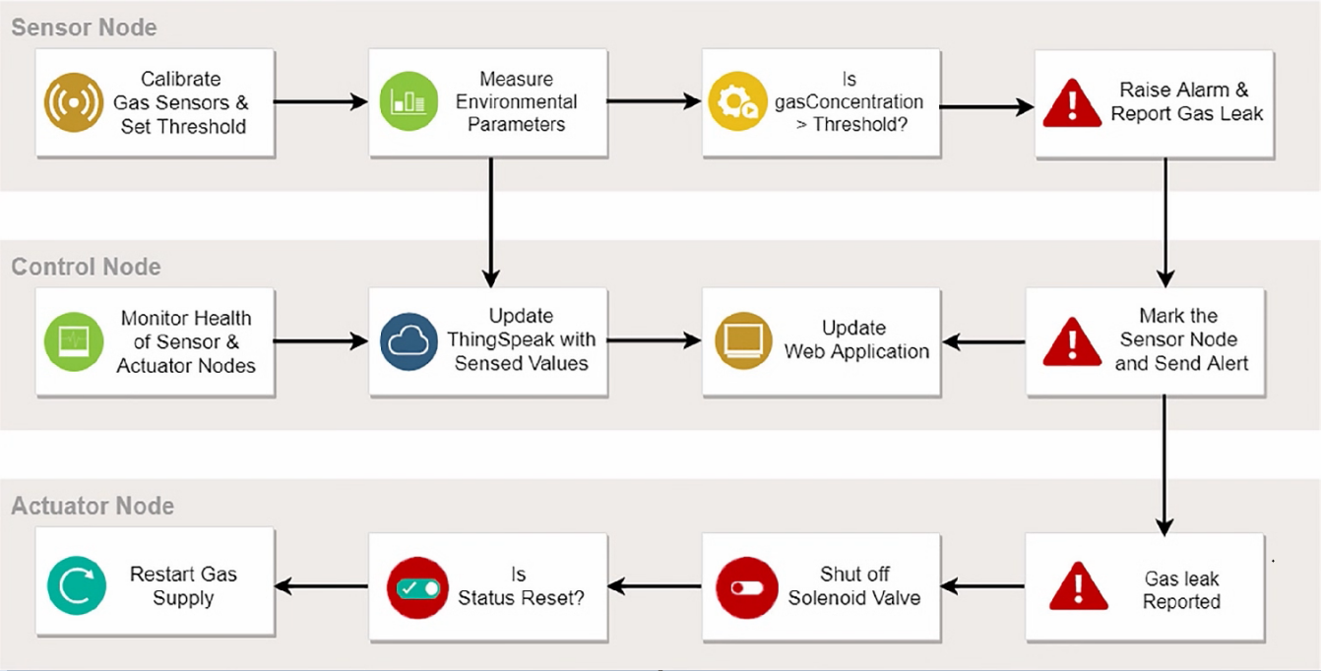

The sensor output will be used as digital input by Arduino. The buzzer will start to tune and the LCD will display "Gas detected: Yes" if the sensor output is high. The bell won't tune and the LCD will display "Gas detected: No" if the sensor output is low. The buzzer typically consists of a number of switches or sensors that are connected to a control unit that can identify which button was pressed or whether a predetermined amount of time has passed. The buzzer also typically illuminates a light on the appreciate button or control panel and emits a warning sound in the form of a continuous or sporadic buzzing or beeping sound.

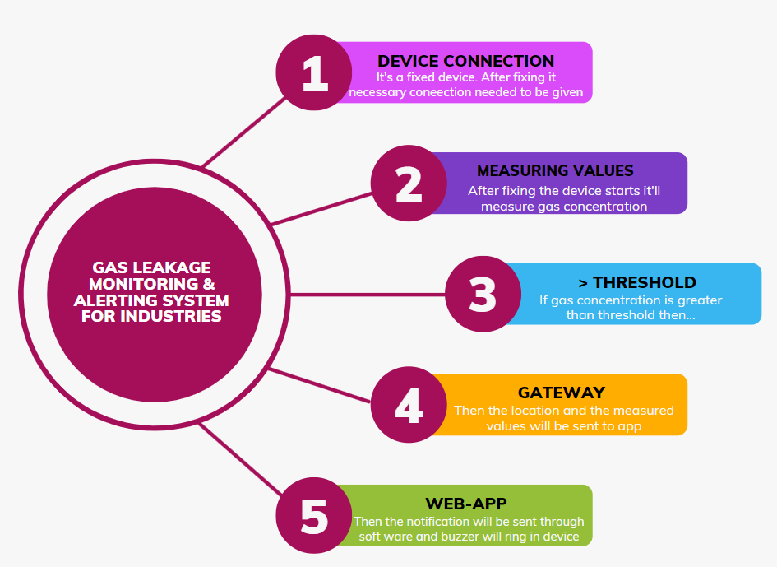

**Circuit Diagram :-**



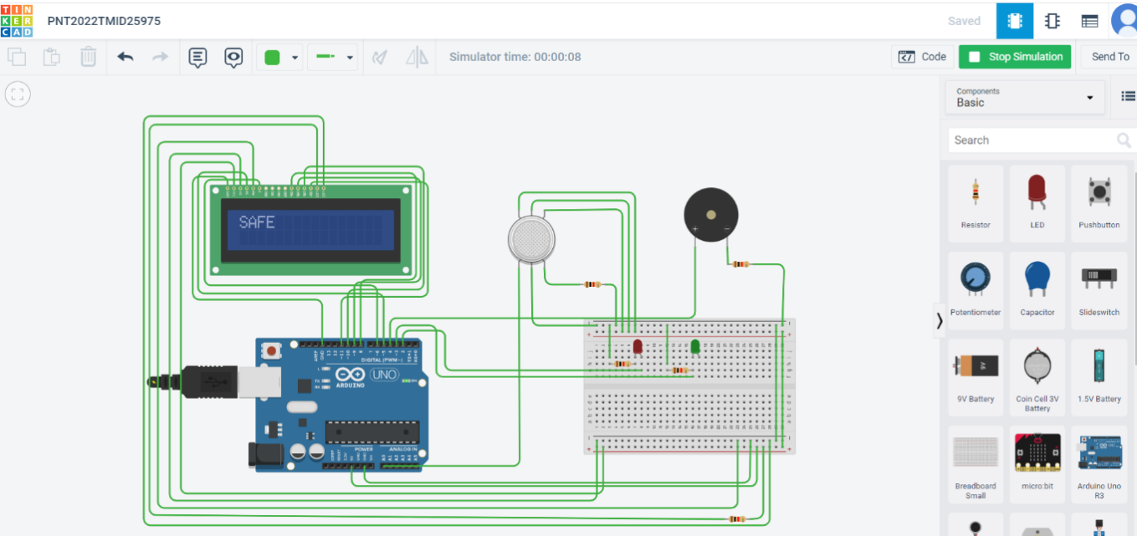

**Solution Statement:-**

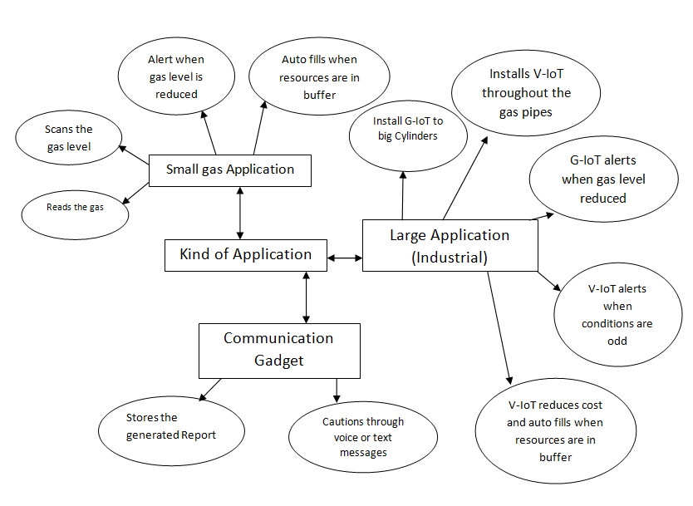

The alarm, which includes a buzzer, will sound if the system detects a gas concentration in the air that is higher than the safety limit, alerting the users at home to the anomalous situation and enabling them to take any necessary action. The smell of gas in the house is the most obvious indicator of a leak. However, there are specific bodily symptoms that you might experience if there is a carbon monoxide leak. The output of this study is that the leakage will be found and terminated two seconds after it begins. The degree of gas leakage can even be detected by this technology. This is a powerful technique for automatically locating and stopping the gas leak.

Moreover, the fire incidents are also averted by cutting off the power supply. The concept of gas detection and control can be applied broadly across a range of industries. This system can be put in any room, including a restaurant in a hostel. This may help to lessen mishaps brought on by gas leakage in residential areas in addition to in comparable commercial settings. There are 180 million people living in our nation, and our product is affordable, will avoid many mishaps, and will protect countless homes, businesses, and lives.

**Output:-**

**Code:**

#include <LiquidCrystal.h>LiquidCrystal lcd(5,6,8,9,10,11); int redled = 2;int greenled = 3;int buzzer = 4;int sensor = A0;int sensorThresh = 400;void setup(){pinMode(redled, OUTPUT);pinMode(greenled,OUTPUT);pinMode(buzzer,OUTPUT);pinMode(sensor,INPUT);Serial.begin(9600);lcd.begin(16,2);}void loop(){ int analogValue = analogRead(sensor); Serial.print(analogValue); if(analogValue>sensorThresh) {digitalWrite(redled,HIGH);digitalWrite(greenled,LOW);tone(buzzer,1000,10000);lcd.clear();lcd.setCursor(0,1);lcd.print("ALERT");delay(700);lcd.clear();lcd.setCursor(0,1);lcd.print("EVACUATE");delay(700);}else{digitalWrite(greenled,HIGH);digitalWrite(redled,LOW);noTone(buzzer);lcd.clear();lcd.setCursor(0,0);lcd.print("SAFE");delay(700);lcd.clear();lcd.setCursor(0,1);lcd.print("ALL CLEAR");delay(700);} }

**Conclusion:-**

We can infer from the project's performance that the system's detection of LPG gas leakage is remarkable. Useful for both residential and commercial purposes. We can use this technique to save lives in dangerous situations. The GSM module indicates an alert. Propane, CO2, and other gases are detected by a sensor node. Power usage and transmission range are estimated. The sensor was constructed using simple techniques and an Arduino UNO Micro controller.

**References:-**

* <https://www.academia.edu/81270911/IoT_Based_LPG_Gas_Level_Detection_and_Gas_Leakage_Accident_Prevention_with_Alert_System?f_ri=241365>
* <https://www.semanticscholar.org/paper/Gas-leakage-detection-and-alerting-system-using-Uno-Shahewaz-Prasad/176f9c7c278524425b7c9ff9491ee1f2a0095b4b>
* <https://jeeeccs.net/index.php/journal/article/view/172>
* <https://www.pramanaresearch.org/gallery/22.%20feb%20ijirs%20-%20d539.pdf>
* <https://www.researchgate.net/figure/Comparison-of-gas-detection-sensor-technologies_tbl2_285988329>
* <https://ieeexplore.ieee.org/document/8822055>
* <https://ijsrcseit.com/CSEIT1951128>